**PKS 0405-123**

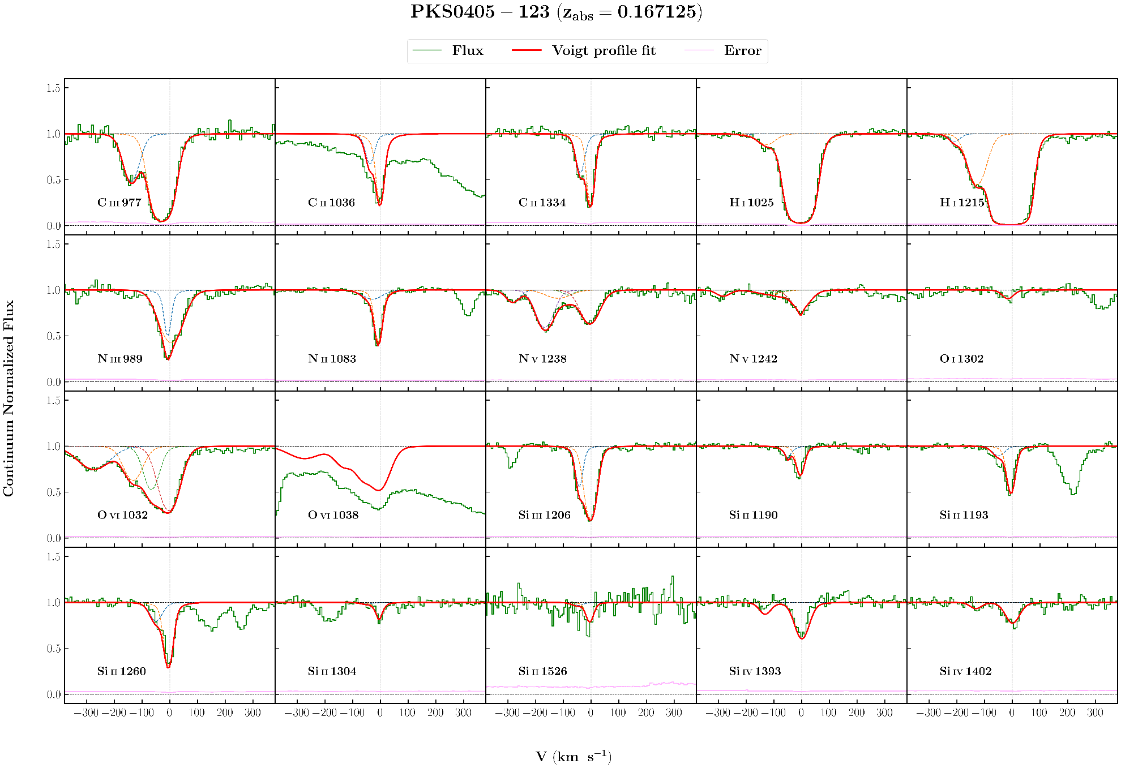

**Parameters:**

OI 0.1670678940 0.0000176844 23.02115 7.39605 13.521197 0.079622 1.0413526

CII 0.1669786826 0.0000062986 15.59504 1.94013 13.758576 0.023887 1.4154481

CII 0.1671228273 0.0000028272 5.79451 1.47549 16.266556 0.116043 1.4154481

CIII 0.1665840346 0.0000060858 32.43470 2.47079 13.448244 0.020931 2.0004837

CIII 0.1670200487 0.0000000000 37.42207 1.53977 14.328727 0.040731 2.0004837

NII 0.1670159255 0.0000251942 43.90854 5.40351 13.473813 0.086758 1.3031318

NII 0.1670973403 0.0000015129 12.02378 0.88854 14.110452 0.019229 1.3031318

NIII 0.1670958057 0.0000000000 9.00614 3.85335 14.062759 0.083836 2.9783065

NIII 0.1671425512 0.0000000000 49.53272 2.15373 14.431487 0.021747 2.9783065

NV 0.1660276744 0.0000111351 30.19929 0.07552 13.251035 0.051538 2.3762347

NV 0.1666637610 0.0000007446 58.91453 9.12664 13.321390 0.080045 2.3762347

NV 0.1668100994 0.0000522836 23.71311 11.87845 12.770166 0.190826 2.3762347

NV 0.1671120228 0.0000083938 42.91592 2.78868 13.885519 0.025991 2.3762347

HI 0.4088164888 0.0000122096 39.06574 2.20217 14.289471 0.028058 2.3762347

SiIII 0.1669600553 0.0000108277 12.61548 3.51379 12.657691 0.097370 1.6171621

SiIII 0.1671199006 0.0000066804 22.30275 2.00412 13.283041 0.028921 1.6171621

SiIV 0.1666159870 0.0000007854 24.68000 4.98609 12.611939 0.058900 1.5066304

SiIV 0.1671318528 0.0000047325 30.60401 1.82337 13.254543 0.017492 1.5066304

SiII 0.1669340418 0.0000196011 26.06574 7.69560 12.541652 0.087007 4.6353122

SiII 0.1671099026 0.0000027384 15.43042 0.11936 13.236618 0.021960 4.6353122

HI 0.1663168865 0.0000349434 24.13660 8.56398 12.540306 0.094674 0!

HI 0.1666310169 0.0000064815 39.39690 3.56252 13.690634 0.028655 0!

HI 0.1671090199 0.0000015537 39.00313 0.59919 15.675510 0.035557 0!

OVI 0.1660591159 0.0000008501 74.45399 4.57901 14.051781 0.022849 3.0168067

OVI 0.1666120404 0.0000300694 41.14217 2.81455 14.046605 0.099491 3.0168067

OVI 0.1668689314 0.0000181440 32.08259 2.40961 14.108044 0.174587 3.0168067

OVI 0.1671161016 0.0000161637 42.81323 3.22252 14.488843 0.048599 3.0168067

**Comments:**

OVI :

OVI 1038 seems to be contaminated from Lya at z=0, so only OVI 1032 has been fitted.

Shows a hint a 5th component blueward of 1st component. But fitted with 4 components as of now.

CII :

CII 1036 seems to be contaminated, so only CII 1334 has been fitted.

CIII :

Great fit

OI:

Very shallow

NII:

two very nearby components

NIII:

maybe a little contamination on the wings

NV:

contamination from Lyb from z=0.408816

SiIII:

great fit!

SiIV:

Low SNR 1st component

Should consider more uncertainity in logN of this component

SiII:

SiII 1526 has low S/N, so dropped from fitting

Has other nearby lines, didn't fit now, but could be fitted.

HI:

Lyg contaminated with galactic (ISM) NI 1134

Same problem as always with HI, some show some components, some show other components

**PG 1116+215**

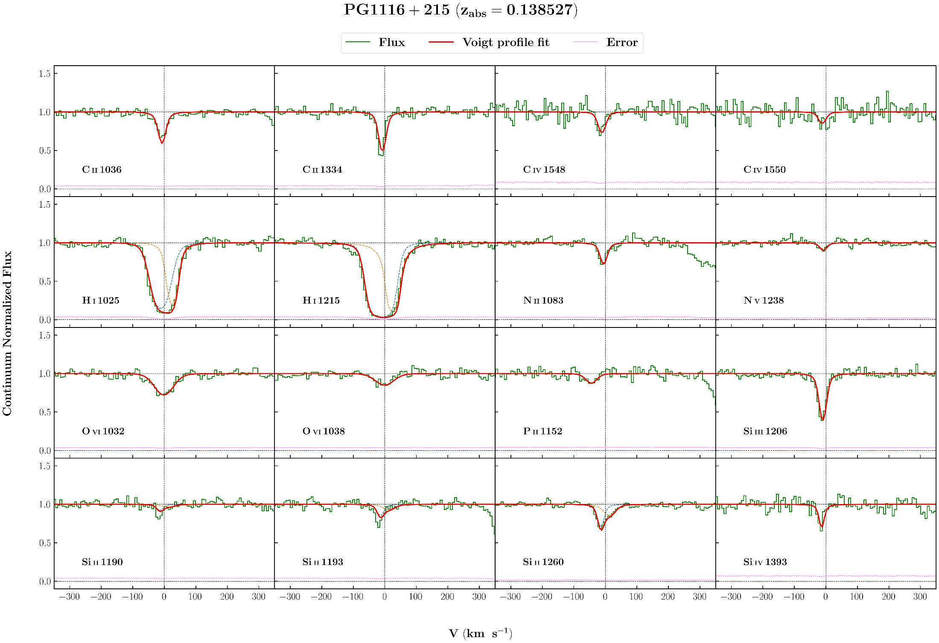

**Parameters:**

NV 0.1385000651 0.0000115965 11.87628 5.52888 12.836957 0.086233 2.2684217

NII 0.1385084544 0.0000047194 8.10911 2.91961 13.607533 0.050692 1.3954045

PII 0.1383589472 0.0000178447 19.17964 7.88945 12.938066 0.092643 1.4472090

SiIII 0.1384926171 0.0000017471 9.50530 0.93572 12.923982 0.042684 0.9345391

SiIV 0.1384799580 0.0000080045 2.21174 66.95132 13.452470 53.133438 0.9681537

OVI 0.1385254830 0.0000007489 35.11151 2.86225 13.838297 0.023462 1.0431347

CIV 0.1384883547 0.0000097724 13.15628 4.41107 13.165207 0.073686 1.1290557

CII 0.1385004601 0.0000023285 9.37152 1.25010 13.850015 0.035949 1.2511136

2 comp

HI 0.1384853538 0.0000115728 28.35612 1.53688 14.897655 0.059584 1.5790103

HI 0.1386254804 0.0000098938 7.25845 0.99193 16.972902 0.123955 1.5790103

3 comp

HI 0.1384949293 0.0000100154 27.16631 1.80149 14.970368 0.053744 1.3869172

HI 0.1385057088 0.0000333245 70.78563 13.64019 13.596925 0.229526 1.3869172

HI 0.1386447375 0.0000085496 6.33212 2.32880 16.039296 1.768212 1.3869172

SiII 0.1384763384 0.0000014679 9.05401 1.36028 12.460401 0.056773 1.6307890

SiII 0.1385768106 0.0000007476 23.13853 3.14293 12.308377 0.042226 1.6307890

**Comments:**

NV:

Weak line

NII:

Shows a little asymmetric right wing, but couldn't fit 2 components

PII:

Very weak line

SiIII:

Good fit

SiIV:

Very narrow line. So error are overestimated.

Errors from chi-sq : b - 0.4 logN - 0.04

OVI:

Good fit

CIV:

Little noisy CIV_1550

Currently both lines are fitted together

CII:

Best what we can get for both the lines, though visually not good.

Fitting one doesn't fit other.

HI:

Not sure how many components to fit. Linelist gives two components for Lya but one for Lyb. Savage et. al fitted 3 components. Currently fitted with 2 components, but none are BLA. Fitting 3 components do gives a large b(~80) for one component but gives low b (~10) for one component also. Other Lyman transitions are not in COS coverage, but Savage et al. used those from STIS to fit.

Fitted with 3 components also. Fit looks better than 2 components.

A 3-component fit is also done, but parameters differ from Savage et al.

SiII:

SiII 1260 clearly shows two components while other line shows a little hint of two components, Currently, fitted with two components.

**H 1821+643**

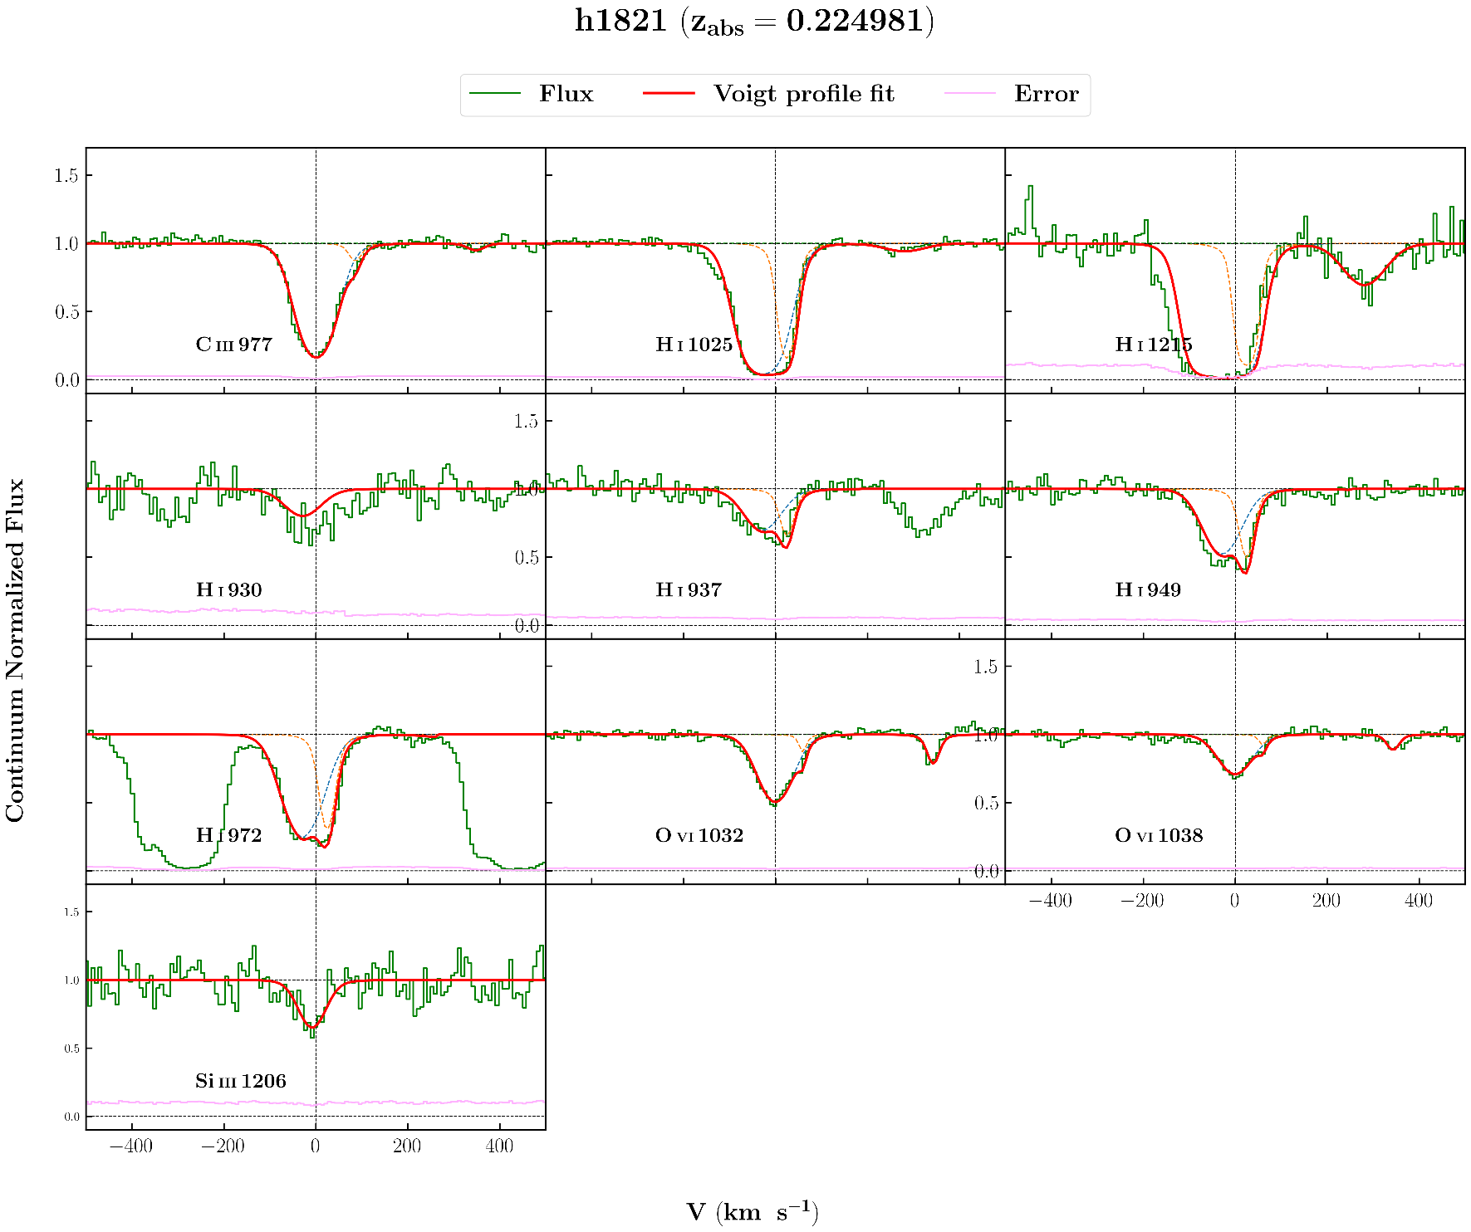

**Parameters:**

SiIII 0.2249516675 0.0000190727 35.03894 6.98373 12.803234 0.058471 1.1836367

C III 0.2249862187 0.0000024163 45.03468 0.91372 13.972539 0.006615 1.3758480

C III 0.2253342276 0.0000130441 13.05162 6.21069 12.471005 0.091765 1.3758480

C III 0.2264055794 0.0000322607 19.72413 13.67432 12.128282 0.146678 1.3758480

O VI 0.2249808289 0.0000036774 45.39677 1.35523 14.243250 0.009108 1.7494653

O VI 0.2252254380 0.0000075716 1.32446 3.45702 13.235705 0.704700 1.7494653

O VI 0.2263856209 0.0000047149 12.65554 2.17167 13.423645 0.028401 1.7494653

H I 0.2248659017 0.0000699081 49.10389 4.35507 15.268288 0.132768 1073

H I 0.2250841123 0.0000687099 14.50097 8.60473 15.012031 0.440466 1073

H I 0.2261303635 0.0006177562 56.59603A 222.81837 13.479715 1.100553 1073

------- 5 component fit ----------

H I 0.2244883407A 0.0000167241 25.70141A 4.85382 13.703704A 0.073213 0 !

H I 0.2248499914A 0.0000056350 37.92007A 1.67322 15.229016A 0.015284 0 !

H I 0.2250839537A 0.0000034979 16.30154A 0.79196 15.080965A 0.026046 0 !

H I 0.2253127537A 0.0000011643 4.83090A 11.31940 12.814194A 0.363671 0 !

H I 0.2261534508A 0.0000000000 59.12604A 10.03322 13.480139A 0.055629 0 !

SiII -0.0004468869A 0.0000045452 24.60621A 1.55019 14.072995A 0.021999 0 !

SiII -0.0001117073A 0.0000034008 41.96336A 1.94160 15.120020A 0.072762 0 !

>> 2.4404780000SZ 0.0000000000 -6.87800A 0.44966 1.000000SH 0.000000 2 !

>> 2.4404780000SZ 0.0000000000 -9.61439A 2.37399 1.000000SH 0.000000 5 !

**Comments:**

SiIII:

good fit

CIII:

Nice fit

OVI:

Good fit, but 2nd component has low b value of ~1km/s.

HI:

HI 930 has low S/N so excluded from fitting. Fitting it with parameters got from other lines don't give good fit.

Absorption on both sides of HI 972 is from ISM Si II 1190 and Si II 1193 lines

Fitted with 5 components also based on Savage et al. but none are bla, max b is 37 km/s

using params from Savage et al. fits Lyman alpha and beta but not others.

And Lyman alpha and HI 930 are shifted to fit.

**3c263**

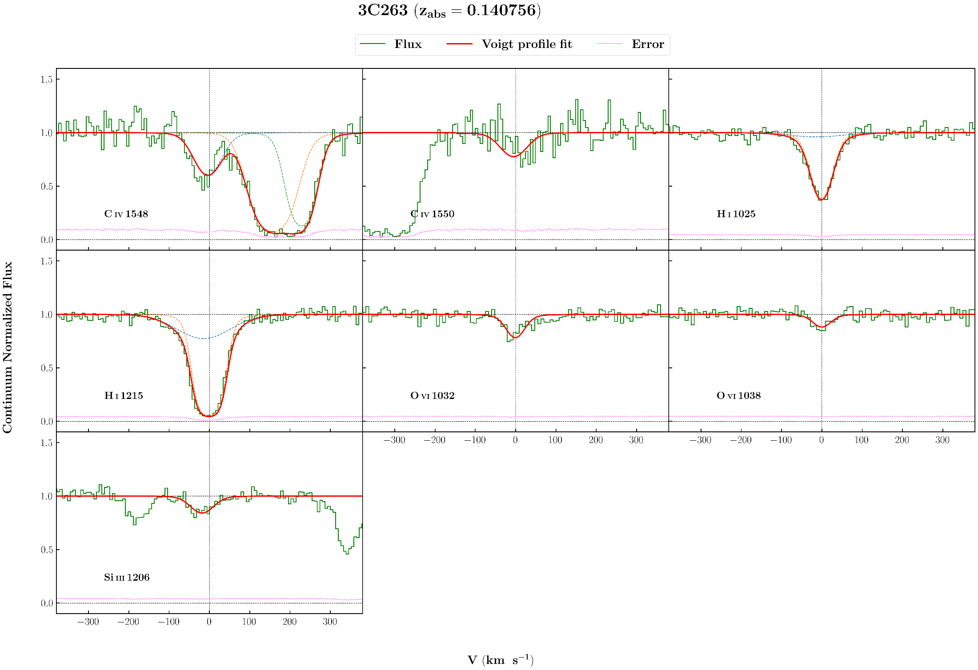

**Parameters:**

SiIII 0.1406880051 0.0000316047 35.31826 10.81290 12.391656 0.090859 5.0449430

CIV 0.1407421423 0.0000141294 41.64629 0.27434 13.733881 0.046205 1.6253947

HI* 0.4535609946 0.0000527059 53.29739 7.70587 14.350000 0.102493 1.6253947

HI* 0.4539039897 0.0000407074 35.20059 5.90167 14.110056 0.175664 1.6253947

OVI 0.1407564505 0.0000092985 25.92999 3.94350 13.627117 0.037619 0.9690515

HI 0.1407019306 0.0000021890 86.81166 10.11454 13.486395 0.064776 0.9745798

HI 0.1407546589 0.0000017485 28.38333 0.69949 14.494759 0.022348 0.9745798

**Comments:**

SiIII:

Good fit. Has OVI line on the left, didn't fit now, but could be fitted.

CIV:

CIV 1548 has contamination on right from Ly alpha lines from z=0.453561 and 0.453904

OVI:

Good fit

HI:

Good fit

**PG 1216+069**

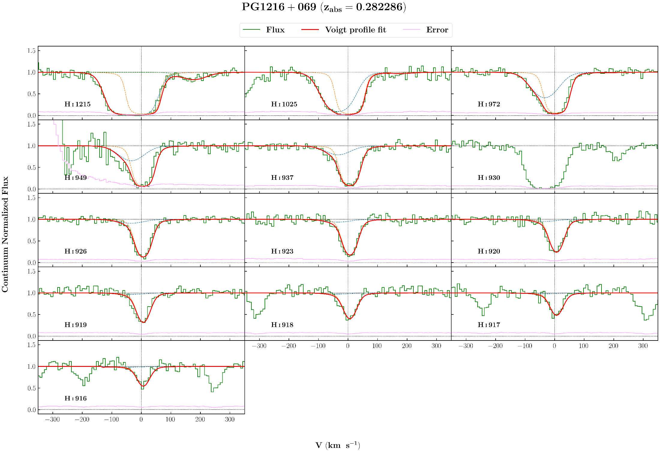

**Parameters:**

SiIII 0.2822862911 0.0000064517 14.42933 2.55067 12.915199 0.051460 1.2492419

CIII 0.2820546410 0.0000152303 31.81940 5.15178 13.329553 0.047488 1.1541641

CIII 0.2823093542 0.0000049554 15.86702 1.99999 13.764524 0.072034 1.1541641

OVI 0.2819925351 0.0000253053 58.04835 9.44008 13.934038 0.050426 0.9411453

OVI 0.2823717093 0.0000111878 12.42547 5.10012 13.539429 0.086084 0.9411453

H I 0.2821448840 0.0000033813 52.14798 2.51606 15.101463 0.048496 7.4562684

H I 0.2823165314 0.0000044867 22.12598 0.80737 16.396308 0.034016 7.4562684

H I 0.2830552986 0.0001023505 52.71422 9.50178 13.147276 0.179886 7.4562684

**Comments:**

SiIII:

Good fit

CIII:

Good fit

OVI:

Excluded OVI 1038 from fit, looks little noisy. and I component comes to be quite (b~58 km/s) broad

HI:

Ly6 contaminated with galactic SiII, so excluded from fit. All the rest transitions are used to fit the lines.

Tried excluding Ly16 and Ly17 from fit beacause of low S/N, but got same parameters.

**PKS 0637-752**

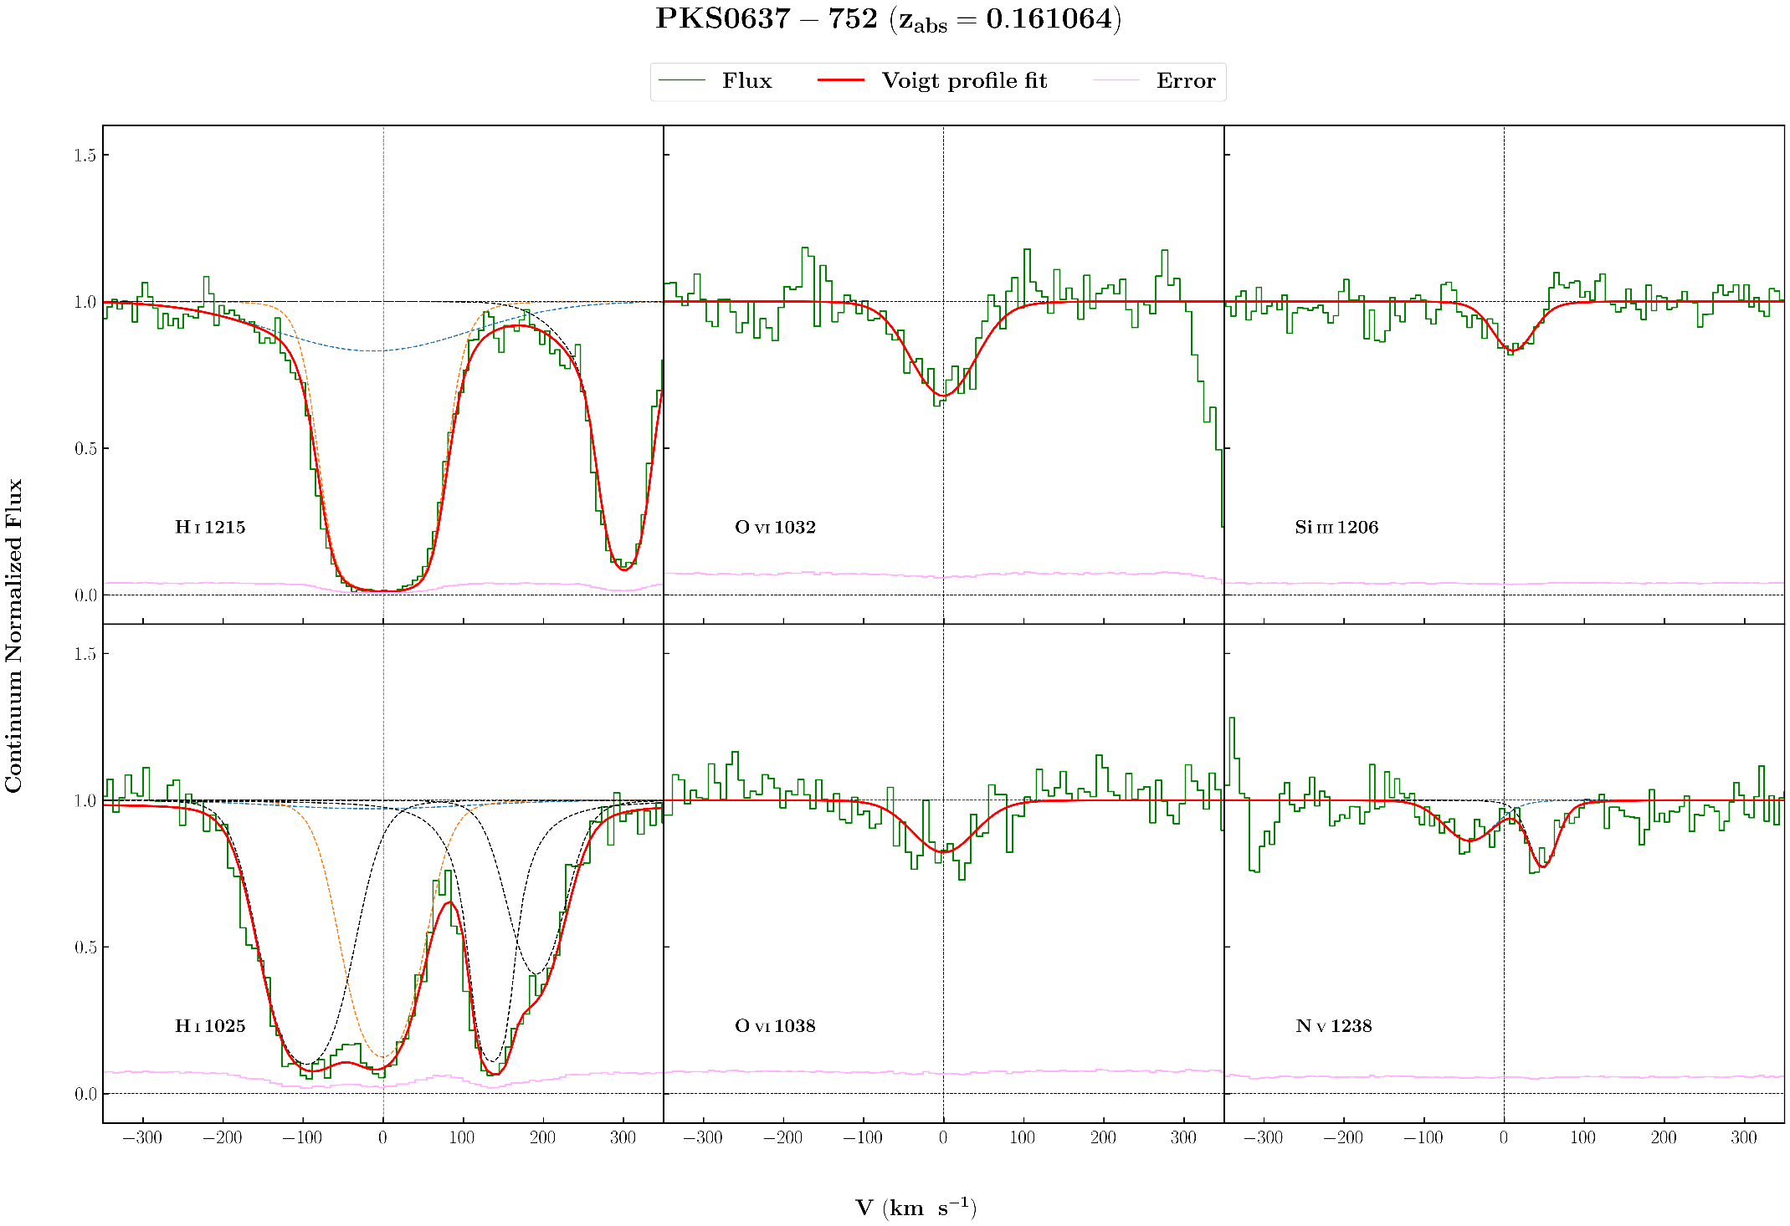

**Parameters:**

NV 0.1608985995 0.0000227670 39.95812 9.39697 13.367249 0.070298 0.8272583

OVI 0.3864321261 0.0000123205 19.48790 4.38150 13.825470 0.056173 0.8272583

SiIII 0.1611078712 0.0000167654 30.38187 6.63407 12.366335 0.063146 1.9651155

O VI 0.1610644353 0.0000121397 48.32662 4.70570 14.021777 0.030330 0.8993105

HI 0.1610130616 0.0000084046 162.25224 20.67768 13.604240 0.062069 1.2342256

HI 0.1610617384 0.0000018106 45.42251 0.80820 15.005948 0.023664 1.2342256

SiII 0.0001130000 0.0000000000 50.06230 2.05285 14.452210 0.017952 1.2342256

SiII 0.0008850000 0.0000000000 8.95468 1.03069 16.512444 0.134299 1.2342256

SiII 0.0010700000 0.0000000000 38.59906 3.71834 13.917729 0.034489 1.2342256

HI 0.4527308061 0.0000372417 72.84594 14.19627 14.686389 0.104003 1.2342256

HI 0.4527906587 0.0000031283 24.87858 1.61283 15.396251 0.031272 1.2342256

**Comments:**

NV:

Has OVI 1038 from z=0.386432 on right. Not much strong line, fitted with one component.

SiIII:

Good fit

OVI :

Satisfactory fit

HI:

Good fit. Ly-a has Ly-g on right,this contamination is fitted with two components. Ly-beta has contamination from galactic SiII lines.

This contamination is fitted with 3 components.

Ly-a has very large b value (~162 km/s) and Ly-b has almost negligible contribution from the first component.

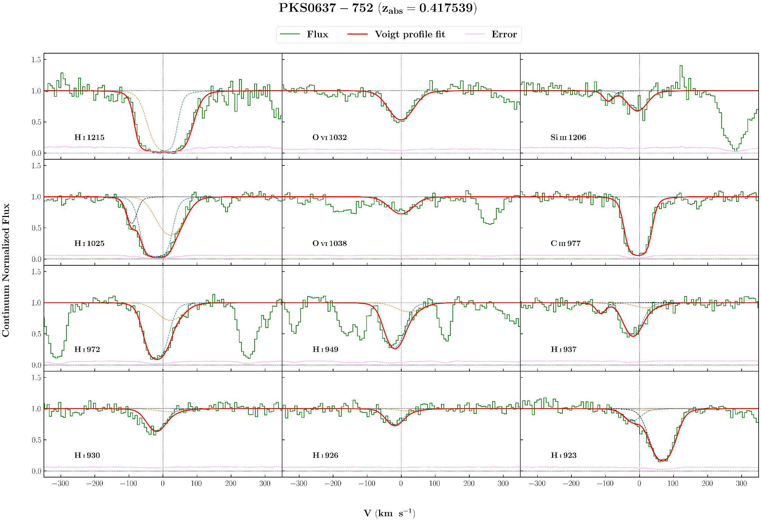

**Parameters:**

SiIII 0.4175130206 0.0000211617 34.91085 6.86884 12.737918 0.059316 1.5113336

NiII 0.0000808917 0.0000237038 15.51364 12.12001 13.692415 0.177561 1.5113336

CIII 0.4175202653 0.0000028561 24.33120 1.99629 14.439747 0.147302 1.3255507

OVI 0.4175392950 0.0000030003 42.38505 6.17585 14.193295 0.045983 2.2976009

HI 0.4174466395 0.0000073949 30.04463 1.45930 15.410618 0.026802 5.8103201

HI 0.4176439851 0.0000029802 45.74984 3.73329 14.611473 0.065552 5.8103201

NIII 0.4685407421 0.0000182180 15.47755 5.88010 13.868735 0.093377 5.8103201

CI 0.0000286262 0.0000000000 14.20873 16.87339 13.454811 0.224179 5.8103201

HI 0.0766894119 0.0000072537 35.22731 2.99336 14.058239 0.036137 5.8103201

**Comments:**

SiIII:

A little doubt on continuum. Contaminated with galactic NiII 1709.

CIII:

Good fit. Seems like something is there at right wing. Nothing in the line list

OVI:

Good fit

HI:

Lyb contaminated from NIII 989 from z=0.468541

Lye contaminated from galactic CI 1328

Ly8 contaminated from Lya from z=0.076689

**PG 0003+158**

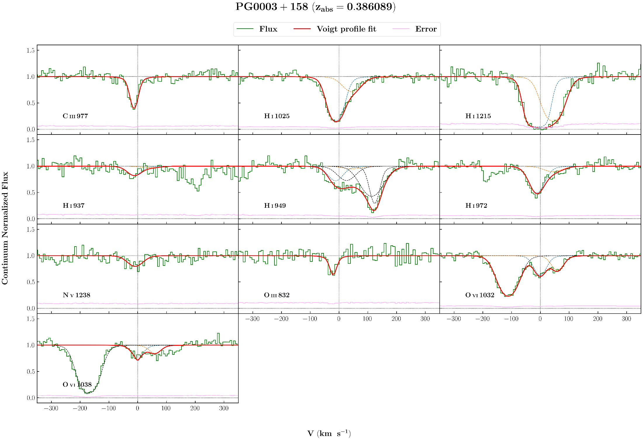

**Parameters:**

OIII 0.3859963705 0.0000109891 9.22504 5.32969 13.925146 0.078022 0.7288151

CIII 0.3860328074 0.0000042047 13.18990 1.72901 13.348258 0.054476 1.1080074

NV 0.3860519589 0.0000030260 33.27024 11.09355 13.490832 0.107530 0.8757697

OVI 0.3860898183 0.0000102510 24.97923 3.23672 13.866540 0.039833 1.8531731

OVI 0.3863678932 0.0000141009 24.63515 4.43904 13.706564 0.056352 1.8531731

HI 0.1761508226 0.0000037859 40.07918 1.38160 13.974410 0.012782 1.8531731

HI 0.4013657366 0.0000029580 36.50319 0.94255 15.010568 0.015618 1.8531731

HI 0.3860364236 0.0000059026 28.84508 0.35073 14.806274 0.034217 1.7032416

HI 0.3862958848 0.0000452331 39.51601 4.36752 14.100657 0.046946 1.7032416

HI 0.0829798838 0.0000395251 36.62992 10.88436 13.283344 0.146570 1.7032416

HI 0.4218236868 0.0000018291 44.71649 6.12392 16.018647 0.078207 1.7032416

CIII 0.3479516031 0.0000122275 9.58664 18.48953 14.138070 3.994817 1.7032416

**Comments:**

OIII:

Good fit

CIII:

Good fit, have contamination on right from OVI 1038 from z=0.305723, outside the wing.

NV:

Good fit, but low S/N

OVI:

Good fit for OVI 1032. OVI 1038 has an unidentified contamination on right of the component II. So only OVI 1032 is used to fit the lines.

OVI 1032 has contamination from Lya from z=0.1761508 and OVI 1038 has contamination from Lyb from z=0.401366 on left.

HI:

Used all the lines for fitting

HI 949 contaminated with HI 926 from z=0.421823, Lya from z=0.082980 and CIII 977 from z=0.347952

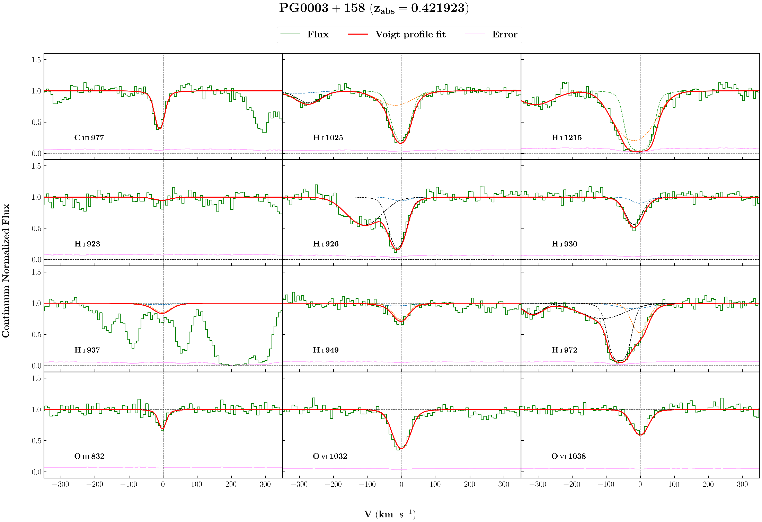

**Parameters:**

CIII 0.4218762005 0.0000040204 13.14459 1.45091 13.346653 0.035842 0.8637854

OIII 0.4219146687 0.0000085956 7.23996 4.67080 13.832020 0.125495 0.6835363

OVI 0.421923350 0.0000043520 26.83073 1.38670 14.267718 0.015397 1.0312603

HI 0.4204697150 0.0000313788 66.48435 9.68352 13.365537 0.049662 0.9691570

HI 0.4218351688 0.0000038970 63.62130 3.47858 14.167993 0.044724 0.9691570

HI 0.4219129516 0.0000039498 26.13170 0.95837 14.711763 0.023729 0.9691570

HI* 0.1986591353 0.0000015914 43.77986 7.49670 13.135022 0.055794 0.9691570

HI* 0.3467814490 0.0000238784 33.94157 8.13889 13.797861 0.071591 0.9691570

HI* 0.3476948073 0.0000804098 84.45255 13.54757 14.311238 0.114818 0.9691570

HI* 0.3479182619 0.0000042410 24.51112 2.54602 15.107351 0.085348 0.9691570

HI* 0.0829762844 0.0000150895 61.77138 6.34206 13.729497 0.031902 0.9691570

HI* 0.2901813699 0.0000073792 26.21305 2.57820 14.219829 0.028086 0.9691570

CIII* 0.3479462931 0.0000051519 20.93082 2.17136 13.874491 0.060940 0.9691570

**Comments:**

CIII:

Good fit

OIII:

Good fit, but a little less chi-sq of 0.68

OVI:

Good fit. Currently fitted with one component. OVI 1032 has something on the right wing. Fitting two components give a good fit for 1032,

but not for 1038, could be subjected to continuum.

HI :

HI 1025 : contamination from Lya from z=0.198659

HI 972 : contamination from Lyb from z=0.346781,0.347695,0.347918

HI 930 : contamination from Lyb from z=0.290181

HI 926 : contamination from Lya from z=0.082976, CIII 977 from z=0.347946

HI 937 badly contaminated from galactic CII, CIII from z=0.365110 so excluded from fit, HI 923 was also excluded due to low S/N